Issue 223 - September 2021

From Jason’s Desk
Dear Residents,

What a month it has been for everyone here at Carmel, actually the whole country, with the Government locking us down once more because of a COVID outbreak.
I firstly just want to start by congratulating all of you on a sterling effort to meet the Government protocols and keeping everyone safe thus far. This is not always easy and I understand the personal frustrations sometimes regarding meeting these protocol perimeters and how it effects some in the village more than others. In saying this, now we are in ALERT LEVEL 2, I hope this has relieved some of the constrictions and life is somewhat back to normal for you all.
Management and staff have been kept very busy during this time. I would like to take this opportunity to acknowledge our staff and personally thank them, for going the extra mile during this time. For their patience, hard work and “nothing is too much trouble attitude”. Thank you team.
Construction on our ramp at the back of the Centre is looking good and should be ready for more concrete to be poured this week. Once again, thank you to the residents at that end of the village who have been put out during this time. I am sure that it will be well worth the inconvenience once finished.
The bathrooms in the Community Centre, look to be have been delayed a couple of weeks due to Covid and contractors having limited materials. We will however, keep you informed with a start date in due course.
Just a quick note to say that we have not forgotten about the palm fronds that need to be trimmed. Our contractor just had a first baby the week he was going to start and then Covid hit us. This has been booked in. Thank you for your patience regarding this.
It is with sadness that Adrian has retired. We will miss his hard work ethic and cheerfulness around the village as a staff member. We wish him all the best as he has more time to put his feet up. On behalf of management, Adrian, thank you so much for everything you have done for us and the residents. You have been a real blessing to the team.
The family is well and both boys are back at work and school. They enjoyed the time off and Dad got plenty of jobs done around the house, ha ha.
Please continue to stay safe, look out for each other, be kind and we will get through this together.
Kind Regards - Management

CARMEL COUNTRY ESTATE RESIDENTS’ ASSOCIATION INC. COMMITTEE ELECTED FOR YEAR AUGUST 2021
TO AUGUST 2022.

POSITIONS:
Chairperson – Trish Aplin, Unit 80, Phone 027 6358781.

Vice-Chairperson – To be decided upon.

Secretary: - Jan Garrett, Unit 39, Phone 021 2942934. Email is jangarrett9@gmail.com.

Treasurer: - Sue Fox, Unit 105, Phone 07 544 9662. Email for accounts and correspondence is ccevillage.treasurer@gmail.com.

COMMITTEE MEMBERS:
Sue Ede - Almoner
Unit 120, Phone 07 5440811

Bill Hancock
Unit 126 – Phone 07 5443813

Ray Hayward
Unit 122 – Phone 07 5443328

Carole Condor
Apt D - Phone 07 5443551

Ces Steele
Unit 30 – Phone 07 5448128

Your new residents committee have recently met together.

Annual Subscriptions to the Residents Association remain at $10 per person.

Please pay our Secretary, Sue Fox, Unit 105, or via internet banking.
Account number:
38 90200 12511 900

Just ask if you have any questions.

SITUATIONS VACANT:
Hiring Now. Time to update your CV. Volunteers are required to be rostered on the following:

- GOLF CART DRIVERS:
Rostered for transporting residents to and from social events:
Guidelines and familiarisation offered.
Contact: Eddie Perrett, Unit 27. Phone: 027 4372378.

- KITCHEN ROSTER:
To assist the committee. Kitchen Helpers are required for weekly Happy Hours, monthly catered dinners, and monthly residents’ morning teas. Other events Include ANZAC Day, the Resident’s Association AGM, BBQ’s, Pot Luck Dinners, Fish and Chip nights and Concerts.
Please contact our Chairperson, Trish Aplin, Unit 80. Phone: 027 6358781.
- RAFFLES:
Assist with sales of weekly raffles at Happy Hours and preparing tickets. Also, to assist with the sale of extra raffles eg: Christmas hampers. Contact: Jan Garrett, Unit 39 on phone 021 2942934.

4) BAR PERSONS:
The Bar is opened for Friday Happy Hours and monthly catered dinners. Plus special events eg: Pot Luck dinners and the Melbourne Cup.
Contact: Ray Hayward, Unit 122, phone: 07 5443328.

The more volunteers we have, the lighter the work load. All of the mentioned contacts are happy to explain the duties and time involved.

Rate Rebate Application:
The Tauranga Council will be at the Community Centre on Wednesday 13th October 11:15 am to 12 noon only. For those that require assistance with their rates rebate form. If you are eligible. Remember, forms are available from the office. Any questions, please just phone the office on 07 544 5553.

Volunteer Weekend Hosts:
Remember new volunteers are always welcome. There is a criteria. Our next meeting is to be held in the Library on Tuesday 19th October 2021 at 10.00 am. The roster will be revamped due to the Centre being closed at the weekends, during this time. Any questions, please just phone Katrina at the office on
07 544 5553.

It is not the mountain we conqueror, but ourselves,
Sir Edmund Hillary.

POWER OUTAGE
Community Centre
The power will be off between 9.30am and 2:30pm in the Centre on Wednesday 15th September. The power will be off in some of your units also, if an individual power provider has notified you of this. We suggest that you move your vehicle out of the garage and plan ahead accordingly. Perhaps go out for the day, and visit family or friends. Our phones will be down at the Centre. You can walk up to see us if needed and our team will be out and about. The shopping bus to Bayfair will be operating in the morning as usual on that day.

PUZZLE CORNER:
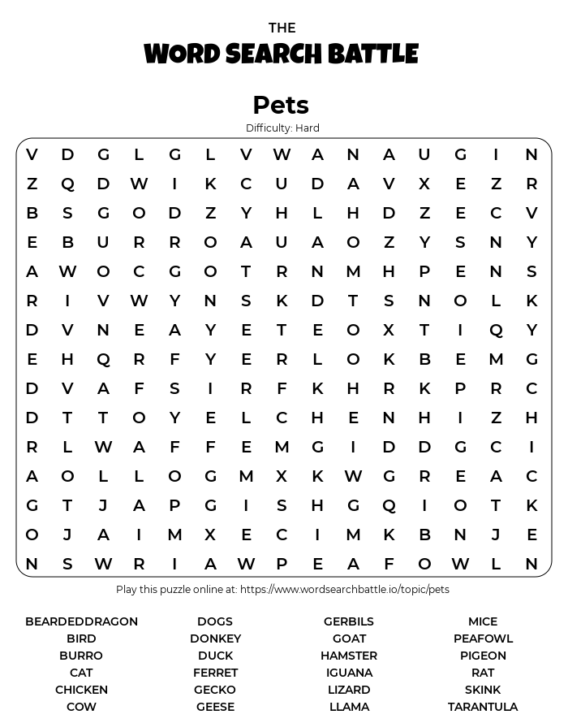
Use a magnifying glass if necessary.

HAPPY BIRTHDAY in September to: Jeanette Haskell, Paul Dunn, Vivienne MacDonald, Dawn Reid, Gillian Insley, Robin Thurston, Dawn Roe, Jack Rowling, Mary Stowell, Jan Korstanje, Anne Rowlands, Alison James, Warren Wilson, Nancy Clark and Adrian van Noppen.

RECIPES:
This month we thought we’d give you two simple recipes that complement each other.
ROASTED PUMPKIN SOUP -
1kg Pumpkin
3 cloves garlic
1 medium brown onion, peeled and chopped.
1 tablespoon olive oil
3 cups (750ml) chicken stock (or vegetable stock)
1 teaspoon fresh thyme, chopped
2.3 cups (160ml) cream (or milk and a bit of butter).
- Preheat oven to moderately hot (200C or 180C fan bake)
- Place peeled pumpkin, onion and garlic in a large baking dish and drizzle with oil
- Roast for about 40 minutes then remove garlic and put aside. Continue roasting pumpkin and onion until soft.
- Squeeze the roasted garlic out of its skin, then blend or process the roasted vegetables with stock until smooth.
- Place mixture in a large saucepan, stir over heat until hot, stir in cream and thyme.
- Adjust salt and pepper to taste, then add either milk OR cream. Whichever you prefer.
Roasting the vegetables give a depth of flavour but it is not necessary. Pumpkin soup is still tasty by putting the vegetables into a pot and boiling until the pumpkin is tender then continue as above. Some variations: Curried pumpkin soup - stir in a touch of curry powder, add little by little after you blitz it. Ginger - Saute 1 tbsp. finely chopped ginger in ½ tsp of oil or butter then proceed with recipe.
AND to go with this delicious soup, try this Beer Bread.
BEER BREAD - 3 cups plain flour (or use self raising flour and omit the baking powder)
3 tsp baking powder
2 tsp sugar
1tsp salt
375ml beer (or make up the extra with water). If you can’t find beer, cider or plain soda water works just as well.
Preheat the oven to 180 degrees celsius on regular bake and line a small/medium loaf tin with baking paper. Add the flour, baking powder, sugar and salt into a large mixing bowl. Stir to combine.
Pour in the beer/water and stir again to combine into a sticky dough and scrape into the prepared tin with a spatula and smooth out. Sprinkle with toppings you like and drizzle with olive oil. Bake in the oven for 40 minutes. It will have risen, puffed up and be all golden and delicious looking.
Some suggested toppings: Finely chopped onion, grated cheese, a sprinkle of garlic powder, sesame seeds, poppy seeds, or chopped sun-dried tomatoes. Or your choice.
ENJOY. We would be interested to hear if you used any of these “old favourites”. It is now officially spring. However, Pumpkin Soup doesn’t have to be winter fare and the Beer Bread is great at any time.
HAPPY RESIDENTS’ DURING ALERT LEVEL 3
Our recent puzzle and jigsaw day was a success, with a treat enjoyed by all. The sun was also shining.
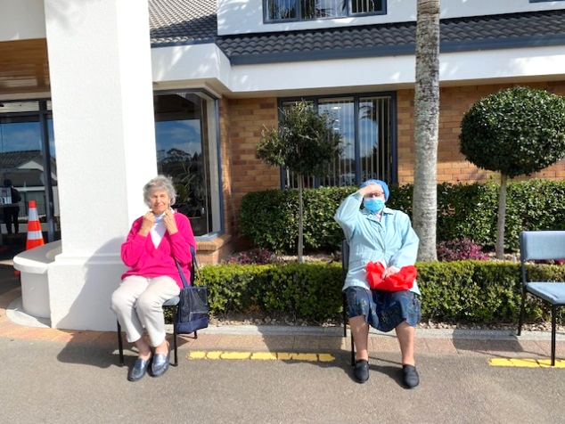
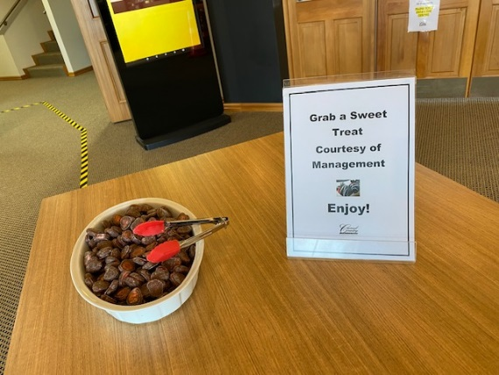
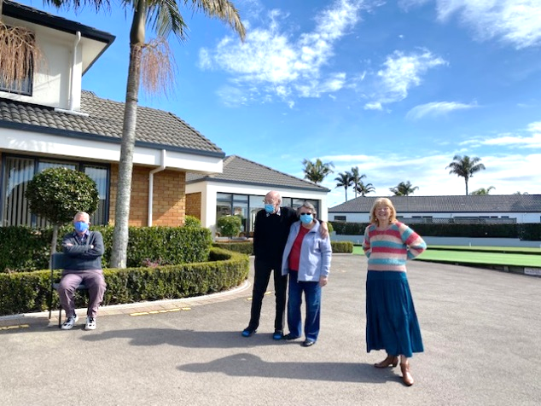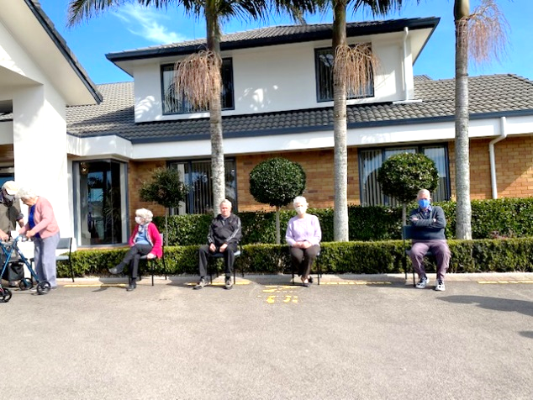
Library News – Peg Cummins:
Now that the latest lockdown is over, please feel free to return your library books. Your librarians are back on duty. It was good to see a number of books to be donated amongst the returns we have dealt with so far. Thank you so much to those who have donated them.
A word about magazines. There seem to be a number of out-of-date magazines turning up. We have decided that we will not be keeping any that are dated earlier than at the beginning of this year. One exception will be the Memories magazine because these do not date in the same way as others.
The library seems to be running well and we are pleased to see that it is being well used. For those who are new to the village, you are welcome to help yourselves to library books. There is no checking out system. When you have finished with the books they are to be placed in the basket just inside the library doors. Happy reading everyone!
THE THINGS WE CAN CONTROL:
Your Beliefs
Your attitude
Your thoughts
Your perspective
How honest you are
Who your friends are
What books you read
How often you exercise
The type of food you eat
How many risks you take
How you interpret the situation
How kind you are to others
How kind you are to yourself
How often you say “I love you.”
How often you say “thank you.”
How you express your feelings
Whether or not you ask for help
How often you practice gratitude
How many times you smile today
The amount of effort you put forth
How you spend / invest your money
How much time you spend worrying
How often you think about your past
Whether or not you judge other people
Whether or not you try again after a setback
How much you appreciate the things you have
— Caleb LP Gunner,
HAIR SALON BACK UP AND RUNNING:
Resident, Vera Edlin having her long awaited hair appointment with our lovely Robyn.
Welcome Back! Great to have the Centre open again.
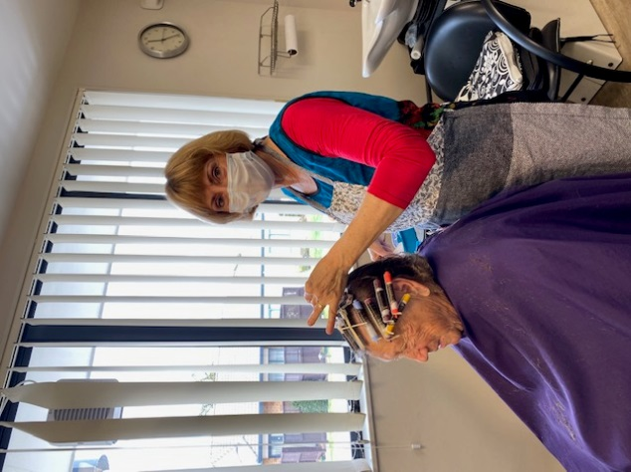
SPRING HEALTH AND SAFETY:
1. Get out in the garden. Gardening is an activity that promotes overall health and quality of life, physical strength, fitness, flexibility, cognitive ability and socialisation.
2. Soak up warm sunshine safely. Spending time outdoors in warm, sunny spring weather improves mood and cognition, Moderate exposure to sunlight for older adults, who are at risk for low vitamin D, strengthens bones and may reduce the risk of, hip fractures, stroke and heart attack. It also protects against depression and insomnia.
To avoid too much sun exposure, wear sunscreen, a wide brim hat, long sleeves and sunglasses.
3. Walk outdoors in nature each day. People who exercised outdoors in natural environments report feeling revitalised and energetic, and experienced less tension, and confusion, than those who exercised indoors, according to an Environmental Science and Technology study. They enjoyed outdoor activity more and were more likely to repeat it.
4. Lighten up your diet with spring seasonal foods. Many fresh, locally grown vegetables and fruits such as asparagus, cucumbers, mushrooms, radishes, peppers, sweet potatoes, rhubarb and strawberries are in season in the spring. Eating seven to 10 servings of vegetables and fruits each day may help to reduce the risk of chronic diseases.
5. Drink more water when exercising. Older adults who drink plenty of water after being physically active outdoors avoid dehydration and reap more cognitive health benefits from exercise. Drinking water when exercising is especially important for seniors since they often have diminished thirst perception. Remember this after using the Carmel gym. There is water available.
SPRING GARDENING:
Edible planting in spring.
Remove surface debris such as leaves or mulch from vegetable beds to help warm the soil. To avoid compaction, wait until soil has dried out sufficiently before tilling. If soil crumbles when you try to make a ball, then it's time to work the beds. Add amendments such as aged compost, manure and trace minerals before planting early crops of lettuce, radishes, kale, peas and onions. Protect young plants from late frosts with a cover or a cold frame .Plant your edibles for enjoyment later on.
MANAGEMENT CONTACTS
Office and Community Centre Jason and Sharlene Rowling
Katrina Goldie/Lisa Wales 07 544 5553 027 472 7658 (Jason)
office@carmel.co.nz
REGULAR CARMEL EVENTS
Every Monday 10am Carmel Singers
Monday 1.00 pm Indoor Bowls (names in 12.50pm) & Rummikub
Monday 7 pm Cards (500)
1st & 3rd Monday in month 10am Bible Discussion in the Library
1st, 3rd, 5th Monday in the month 1.30 pm Carmel Knitters and Craft
Every Tuesday 9.00–12 noon Physiotherapy Clinic
Tuesday 1.00pm Bolivia - Cards
Tuesday 1.30pm Petanque
Tuesday 2pm Men’s Croquet
2nd Tuesday in the month 10am Residents’ Morning Tea
3rd Tuesday in the month 1.30pm Bingo
4th Tuesday in the month 10am Garden Lovers
Every Wednesday 8.45am Village Bus Departs for Bayfair (2 trips)
Wednesday 9.00am Keep Your Feet Strength and Balance
Wednesday 9.00am Outdoor Bowls - names in 8.50am
Wednesday 9.30am Golf Croquet
Wednesday 1.30pm Mah-jong
Wednesday 1.30pm Cards
Wednesday 1.30pm Table Tennis
Wednesday 4.00pm Men’s Social Hour
Every Thursday 10am Health Clinic in Doctors Room
Thursday 1.00pm Scrabble
Thursday 1.00pm Rummikub
Thursday 1.00pm Adult Colouring In
Thursday 1.00pm Indoor Bowls - names in 12.50pm
Thursday 1.30pm Petanque
1st Thursday in the month 6.45pm Quiz Night
1st & 4th Thursday in the month 9.00am Tauranga Organ and Keyboard club
3rd Thursday in the month 9.45am Red Hat Dames
Every Friday 9.00am Outdoor Bowls - names in 8.50am.
Friday 9.30am Golf Croquet
Friday 1.00pm Hobby Group
Friday 4.30pm Happy Hour
Last Friday in the month 8.45am Village bus departs for The Lakes
Every Saturday in the month 9.30am Exercise Class
Saturday 1.00pm Bolivia
Every Sunday 11.00am Carmel Community Church Service
1st Sunday in the month 1.30pm Tauranga Organ and Keyboard Club
3rd Sunday in the month 4pm Movies in the Centre
Every Thursday 8.30am Hair Salon – Glenys ring Carmel office
Every Wednesday 8.30am Hair Salon – Robyn ring Carmel office Carmel Radio Station Daily 107.3

