

From Jason’s Desk Issue 253 March 2024

Dear Residents,

I can’t believe I am typing another newsletter so soon; the time just seems to be disappearing and perhaps that’s on the back of us being so busy.
At present we have quite a few villas undergoing refurbishment, but I am happy to say we are on top of the workload. Interest in the village has been good since Christmas and March will see six new residents moving in. Like I have always said, you the residents are our best form of advertising and it’s pleasing to hear that so many of our new inquiries know people in our village. So, thank you residents and don’t forget, that if your friends are thinking about looking at Carmel, to register their names with Sarah first, so we can pay you your $1000.00 cash bonus.
My boys Jack and Jesse are working in the village over the next two weeks, just to help with jobs around the village, so if you see them, give them some cheek, and tell them to get a haircut, ha ha.
As you know, we have had some issues with some of our Red Robin hedges, especially along the back of the bowling green and up the walkway between units 54 and 46. We have decided not to plant the walkway area again, but to replace the plants with trellis. So, if you are using the walkway, please be careful until our trellis is installed. We have ordered new plants (Camellias)to replace the hedge behind the bowling green, but unfortunately, they will not be here until April/May. I know it looks like a bit of an eyesore, so thank you for your patience.
Your security and protection are of utmost importance to us, so we have installed a security camera that covers the front reception area. This helps us understand who is coming and going and is extra security for our resident weekend hosts.

We are at present also getting quotes for security cameras to be installed at the front gates, we have not had any issues, but it’s good to have that assurance that security is in place if we ever need it. Like I said it’s just that peace of mind for you, our residents.
You may have also noted that two mirrors have been installed at our top gates, so when you approach to go out of the village, you can look at both mirrors and ensure there are no pedestrians coming. Thanks to Gary Ludlam for bringing this to my attention.
I have enjoyed having my brother over from the States for the last two weeks and got the opportunity to spend some time with him at the lake, we had beautiful weather and came away with great memories.
Have a great month ahead and remember look out for those that need that hug, a meal, or a listening ear, you guys are awesome.
Jason & Sharlene


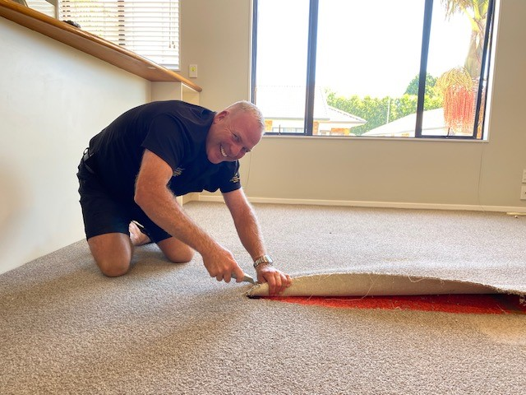
WAIPUNA HOSPICE
CHARITY SHOP
WE ARE IN YOUR NEIGHBOURHOOD!
We offer a free collection service (NOT CLOTHES) in the community for anyone who would like to donate items to Waipuna Hospice Charity Shops.
Clothes must be dropped into a Hospice Shop or the Depot at Fraser Cove.
Thank you for your support, all goods donated help provide funds to support people in our community with life-limiting illness.
FREEPHONE
07 2811755
for a free pick-up
(PLEASE LEAVE A
MESSAGE AND PHONE NUMBER)

HAPPY BIRTHDAY IN FEBRUARY
(Management value your privacy, if you do not wish your Birthday to be acknowledged, please just let the office know)
Cecil Steele, Ted Schischka, Des James, Sue Ede, Annie Duff, Murray Wills, Trudi van Noppen, Gordon Potter, Jan Gibson, Jan Garrett, and Vera Edlin.

ST PATRICK’S DAY PIZZA NIGHT
When:
Sunday 17th March
Where:
Carmel Village Centre
Time:
4.00pm Onwards
Please add your name to the RSVP list in the library by 12.00pm, Thursday 14th March.


With refurbishments well underway around the village, we have all hands on deck to complete the workload.
COMMITTEE BLOG – MARCH 2024
Greetings Everyone. You will be pleased to hear that Graham has been in negotiation with Del Boy's Catering regarding our monthly dinners and we are hopeful that April 20th will be our first opportunity to try him out. More details to come.
If you are interested in the Boys' Day Out to Ross Brothers Muscle Car Museum (which will be happening shortly), keep an eye on the notice board in the Library. Ces Steele will be the contact person.
We have been contacted by Avocado Tours; they offer tours at $20 p/p - only 20metres walking is involved. The tour lasts approx. one hour with another 30 minutes for tastings. Check their notice on the board in the Library if you are interested.
Smallgusta have also been in touch with us. They have a small authentic golf course (not a mini putt) next to the Oropi Hot Pools and Cafe. Gold Card discount - see their pamphlet in the Library.
Our new Arts & Craft Centre will be holding an open day soon. Details will be delivered to your mailbox.
We are looking for volunteers who would be happy to help organise a big Gala Day in October. Please ring Wills 5492255 if you are willing.
Don't forget that Bar Tabs are for sale in the Library from 4.00 - 4.30p.m. every Friday (except Easter weekend, when it will be Thursday 28th) if you want to pay cash instead of paying online.
That's all folks! See you 'round the village.
Cheers,
Suze. IPP



MOVIE AFTERNOON
Cancelled until further notice.
If you are interested in volunteering to run the monthly movie afternoon, please contact the office.
BAYWIDE SMILES
Baywide smiles provide quality dental care at affordable prices. They are currently running two specials.
Comprehensive dental checkup: Was $145, now $79.00.
Comprehensive dental checkup – Scaling Inclusive:
Was $230, now $115.
Call them on 07 578 4622
or visit
www.baywidesmiles.co.nz
REMINDER TO RESIDENTS
This is a reminder that if you need to get hold of staff during the weekend, to contact Jason in the first instance and if Jason is not available to contact Chris.

BUS TIMETABLE
Bus timetables are available at reception, please contact Darice at reception if you would like a copy.


WELCOME TO CARMEL
A very warm welcome to:
Villa 70 – Tom & Robyn Robinson
Villa 126 – John Godfrey

MOBILITY SCOOTER FOR SALE
We have a discovery mobility scooter, in great condition, available for sale.
Price: $2000
If you would like to view or test drive the scooter, please contact Sarah at reception.
Phone 07 544 5553.
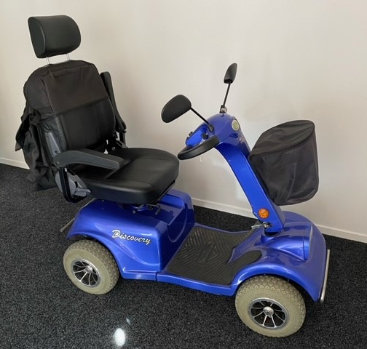

GARDEN LOVERS CORNER
Fourteen very enthusiastic and keen gardeners held an interesting and informative meeting in the sunroom whilst partaking of morning tea.
A very warm welcome was extended to all attendees and an apology was tabled from Noeline Gardner.
Once several plant cuttings and magazines had been passed around the group; Shirley Carter gave a very informative talk about her days as a florist. Oh, to know so much about arranging and keeping flowers fresh.

EDNA’S GARDEN
THREE ROWS OF TURNIPS
Turn up to every meeting
Turn up with a smile
Turn up with new ideas

THREE ROWS OF SQUASH
Squash indifferences
Squash gossip

Squash unconstructive criticism

THREE ROWS OF ‘P’S
Patience
Purpose
Persistence

THREE ROWS OF LETTUCE
Let us be tolerant of one another
Let us enjoy the companionship of our fellow members
Let us be faithful to our aims and objects

Brenda Gaylard
February 2024

LOST PROPERTY
There is a lost property box in the Carmel office. If you find you are missing something, please pop into the office and let us know what you are missing.
Kind Regards,
Sarah Gardyne

PEARCY’S DETAILING
If you are in need of a mobile car cleaning company, Matt and Nadine Pearce specialize in car detailing. The services they offer include:
- Interior/exterior detail clean
- Machine cut and polish
- Ceramic coating
- UV wax protection
- Shower glass door polish
- Couch shampoo
For more information contact Matt or Nadine on 0212345474.

www.pearcysdetailing.co.nz
FREE BOOKHOLDER
Ada Parsons’ family wish to pass on this lovely book holder to a resident at Carmel. Please enquire at reception if you would like it. There is only one available, so it is first in, first served.

FREE TOOTHPASTE
If you would like a free toothpaste sample, courtesy of Baywide Smiles, please enquire at reception. As there are limited numbers, they are available on a first in first served basis.

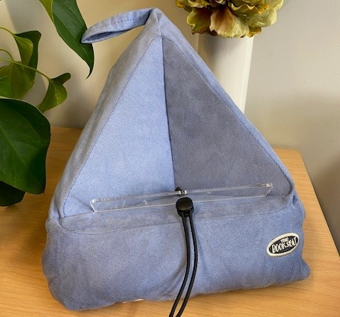

HAIRDRESSER AWAY
Our lovely hairdresser Glenys will be away. Her last day in the Salon will be Thursday, 14th March. She will return Thursday, 18th April.
Terrel will be covering her appointments while Glenys is away. Please call Terrel to make or confirm a booking.
Phone: 027 232 2628

MANAGEMENT CONTACTS
Office and Community Centre Jason and Sharlene Rowling
Darice Hubbard or Sarah Gardyne 0274727658 (Jason)
07 544 5553
office@carmel.co.nz
REGULAR CARMEL EVENTS
Every Monday 10.00am Carmel Singers
Monday 1.00 pm Indoor Bowls (names in by 12.50 pm)
Monday 1.00 pm Rummikub
Monday 1.00 pm Carmel Knitters
Every Tuesday 1.00pm Bolivia – Cards
Tuesday 2.00pm Men’s Croquet
2nd Tuesday in the month 10.00am Residents’ Morning Tea
3rd Tuesday in the month 1.00pm Bingo
4th Tuesday in the month 10.00am Garden Lovers
Every Wednesday 8.45 am Village Bus Departs for The Crossing
Wednesday 9.00am Outdoor Bowls (names in by 8.50am)
Wednesday 9.15am Strength and Balance Class
Wednesday/Thursday 9.30am Golf Croquet
Wednesday 1.30pm Mah-jong
Wednesday 1.00pm 500 Card Game
Wednesday 4.00pm Men’s Social Hour
Every Thursday 10.00am Health Clinic in Doctors Room
Thursday 1.00pm Rummikub and Scrabble
Thursday 1.00pm Adult Colouring In
Thursday 1.00pm Indoor Bowls (names in by 12.50pm)
1st Thursday in the month 6.45pm Quiz night
3rd Thursday in the month 10.15am Carmel Lunch Club
Every Friday 9.00am Outdoor Bowls (names in by 8.50am)
Friday 9.30am Golf Croquet
Friday 1.00pm Hobby Group
Friday 4.00 pm Mix and Mingle
Last Friday in the month 8.30am Village bus departs for Bayfair
(twice per month)
Every Saturday in the month 9.30am Exercise Class
Saturday 1.00pm Bolivia
Every Sunday 11.00am Carmel Community Church
1st Sunday in the month 1.30pm Tauranga Organ and Keyboard Club
3rd Sunday in the month 4.00pm Movies in the Centre
Every Thursday 8.30am Hair Salon – Glenys - ring Carmel office
Every Wednesday 8.30am Hair Salon – Debi - ring Carmel office
Tuesday – Saturday by appointment Beauty Salon – Christine 021 0263 5169

